 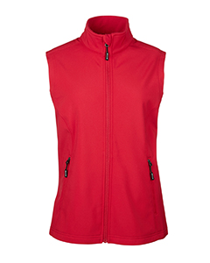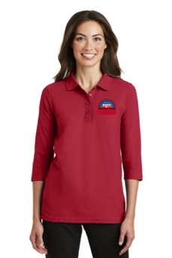 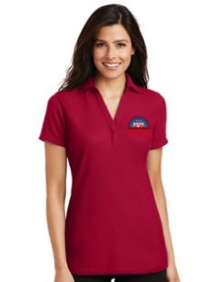

BHRW LOGO Merchandise Order Form

Vest (S, M, L, XL) $ 50

Vest (XXL) $ 53

Short Sleeve Shirt (S, M, L, XL) $ 32

Short Sleeve Shirt (XXL) $ 36

3/4 Sleeve Shirt (S, M, L, XL) $ 36

3/4 Sleeve Shirt (XXL) $ 39

Apron (One Size) $ 20

Order Form:

Name: ____________________________________________________________

Address: ___________________________________________________________

City______________________________ State ____________Zip Code_________

Item: _____________________________Size: __________Price: _____________

Item: _____________________________Size: __________Price: _____________

Shipping Charge for **each** item: $10.00

Total Cost: ________________________

Paid by Cash Check made out to **BHRW**  or Credit Card (Circle One)

**Send or email to : Laurel Regan 3801 NW Loriann Dr Portland OR 97229**

[**Laurel@QOE.net**](mailto:laregan88@msn.com)

VISA/MASTER CARD/DISCOVER _____________________________________

EXPIRATION DATE ______________ CVV#________ Zip Code_________________

NAME AS IT APPEARS ON CARD ___________________________________________

SIGNATURE: __________________________________________________________

Thank You Total Cost: __________________________